1.login:
Use case id | Uc_1
use case name | login
Actors | Customer, Pharmacist, Owner
Precondition | Open Browser , Open web site
Input data | Email and password
Flow of events | 1. User navigates to the login page  2. All websites users will enters their login credentials (email and password).  3. The system validates the credentials. 4. If the login is valid will enter the website, The system grants access to the account and can start shopping  5. Incorrect login credentials entered. “wrong email or password” message will appear .
Response | Either user gains access to their account and can start shopping, or “wrong email or password” message will appear.
Include | Register
Comments | ---
Non function requirement | Security

Use case id | Uc_2
use case name | Register
Actors | Customer, Pharmacist, Owner
Precondition | Open Browser , Open web site
Input data | Name, Email ,Phone number , delivery address, password
Flow of events | 1. visitors select the option to create a new account.  2. visitors provide necessary information (e.g., name, email, password).  3. The system validates the provided information.  4. If the email is valid, The system creates the account.  5. Else if email is invalid the user will returned to the home page as a visitor (Guest)
Response | Either System verifies information and creates account else the user is returned to the home page as a visitor (Guest)
Include | ---
Comments | ---
Non function requirement | Security
2. Register :

3-Search Products :
Use case id | Uc_3
use case name | Search
Actors | Customer
Precondition | Open Browser , Open web site ,Login, go to search bar
Input data | Name of item
Flow of events | 1.Customer enters the name of the desired item into the search bar.  2.System searches for matching items based on the entered name.  3.System displays the matched items to the customer.
Response | System displays match the items
Include | ---
Comments | ---
Non function requirement | Performance, Usability

4-Add Products:
Use case id | Uc_4
use case name | Add
Actors | Customer, Pharmacist,
Precondition | Open Browser , Open web site ,Login, add products
Input data | Select item to add to cart
Flow of events | 1. Customer navigates to the desired item on the website.  2. Customer selects the item they want to purchase.  3. Customer locates and clicks on the "Add to Cart" button associated with the selected item.  4. System verifies the availability of the item and the customer's eligibility to add it to the cart.  5. System adds the selected item to the customer's cart.
Response | System adds the item to the cart.
Include | Login
Comments | ---
Non function requirement | ---

5-Remove Products:
Use case id | Uc_5
use case name | Remove
Actors | Customer, Pharmacist
Precondition | Open Browser , Open web site ,Login
Input data | Select item to Remove from the cart
Flow of events | 1.Customer navigates to the website's shopping cart section after logging in.  2. Customer opens their cart to view the list of items.  3. Customer locates the item they want to remove from the cart.  4. Customer selects the option to remove the item from the cart.  5. System verifies the request and removes the selected item from the cart.
Response | System should remove the item from the cart
Include | Login
Comments | ---
Non function requirement | ---

6-Upload Prescription:
Use case id | Uc_6
use case name | Upload
Actors | Customer, Pharmacist
Precondition | Open Browser , Open web site ,Login, write Prescription
Input data | Prescription
Flow of events | 1.Customer takes a photo of the prescription using their device.  2. Customer navigates to the designated section on the website for prescription upload.  3. Customer selects the option to upload the prescription image.
Response | 1.System receives the uploaded prescription image.  2. System displays the prescription to the pharmacist for review.
Include | Login
Comments | ---
Non function requirement | Usability

Use case id | Uc_7
use case name | Scan barcode
Actors | Customer, Pharmacist
Precondition | Open Browser, Open web site ,Login , Scan barcode
Input data | Scan barcode
Flow of events | 1. Customer opens the barcode scanner feature on the website.  2. Customer scans the barcode of the desired item using their device's camera.
Response | 1.System recognizes the scanned barcode.  2. System retrieves information about the corresponding item.  3. System adds the item to the customer's cart.
Include | Login
Comments | ---
Non function requirement | ---
7-Scan barcode:

8-Choose Payment Method:
Use case id | Uc_8
use case name | Choose Payment Method
Actors | Customer
Precondition | Open Browser, Open web site, Login, navigates to the payment settings section
Input data | Type of payment method , data of payment method
Flow of events | 1. Customer navigates to the payment settings section on the website.  2. Customer selects the option to add a new payment method.  3. Customer provides information about the chosen payment method  (e.g., credit card details).  4. System verifies the provided information.
Response | 1- System saves the information about the payment method.  2 - System verifies the provided information.
Include | ---
Comments | ---
Non function requirement | Security

Use case id | Uc_9
use case name | Check out
Actors | Customer
Precondition | Open Browser , Open web site ,Login, have at least 1 item in cart
Input data | 1-Customer select check out button
Flow of events | 1. Customer adds items to the cart and proceeds to the cart page.  2. Customer reviews the items in the cart and selects the option to check out.  3. Customer selects the desired payment method from the available options.
Response | System processes the order and places it.
Include | Login,Choose Payment Method
Comments | ---
Non function requirement | Performance
9- Check Out:

10- Messaging communication:

Use case id | Uc_10
use case name | Messaging communication
Actors | Customer, Pharmacist
Precondition | Open Browser , Open web site ,Login, go to Messaging communication section
Input data | Message
Flow of events | 1. Customer navigates to the chat feature on the website.  2. Customer selects the option to initiate a new chat session.  3. Customer composes and sends a message to the recipient (e.g., pharmacist).
Response | System delivers the message to the recipient.
Include | Login
Comments | ---
Non function requirement | Usability, Security

11- View sales report :
Use case id | Uc_11
use case name | View sales report
Actors | Owner
Precondition | Open Browser , Open web site ,Login, go to report setting
Input data | Click on Button view sales report
Flow of events | 1. Owner navigates to the sales report section on the website.  2. Owner selects the type of sales report desired (Yearly, Monthly, Weekly, Daily).  3. Owner presses the button to view the selected report.
Response | System displays the sales report according to the selected type, including relevant sales data and metrics.
Include | ---
Comments | ---
Non function requirement | ---

Use case id | Uc_12
use case name | View statistics
Actors | Owner
Precondition | Open Browser , Open web site ,Login, go to View statistics section
Input data | Click on Button view statistics
Flow of events | 1. Owner navigates to the statistics section on the website.  2. Owner selects the type of statistics desired (Best seller, Worst seller).  3. Owner presses the button to view the selected statistics.
Response | System displays the statistics according to the selected type, including relevant data such as sales figures, product performance, etc.
Include | ---
Comments | ---
Non function requirement | ---
12 - View statistics:

Use Case scenario:
1. Login

Id | S_1
Name | Successful login
Related use case | login
Scenario event | The customer called “Omar” will enter his email “ omar@gmail.com” and password “123” then press login button, Omar gains access to their account and can start shopping.

Id | S_2
Name | Failed login
Related use case | login
Scenario event | The customer called “Omar” will enter his email “ omar@gmail.com” and password “255” then press login button, the message “wrong email or password” will appear

2. signup
Id | S_3
Name | Successful Register
Related use case | Register
Scenario event | The customer “Ismail” entered his email Ismail444@gmail.com and his phone number “0101024” and password “Ismail12:” and entered his address the system will create his account successfully

Id | S_4
Name | Failed Register
Related use case | Register
Scenario event | The customer “Ismail” entered his email ismail444.com and his phone number “01099446” and password “Ismail12” and entered his address the message “wrong email” will appear
3. Search Product
id | S_5
Name | Successful Search
Related use case | Search Products
Scenario event | Mohamed, a logged-in customer, searches for a thermometer using the search bar. The system successfully finds matching items and displays them to John, enabling him to choose from various types and brands of thermometers.

id | S_6
Name | Failed Search
Related use case | Search Products
Scenario event | Mohamed, a logged-in customer, searches for a specific brand of sunscreen using the search bar. However, the system fails to find any matching items and displays a message indicating that no items were found, leaving Alice unable to proceed with her desired purchase.

4. Add Product
id | S_7
Name | Successful Add
Related use case | Add Products
Scenario event | Ahmed, a logged-in customer, searches for a "Blood Pressure Monitor" on the Pharmacy website.  Pharmacy verifies the item's availability and Ahmed eligibility to add it to his cart, successfully adding it and confirming his purchase.

id | S_8
Name | Failed Add
Related use case | Add Products
Scenario event | Ahmed, a logged-in customer, searches for a "Hand Sanitizer" on the Pharmacy website. However, the item is out of stock, and Pharmacy is unable to add it to Michael's cart, displaying an unavailability message.
5. Remove Product

id | S_9
Name | Successful Remove
Related use case | Remove products
Scenario event | Mohammed logs into the website, goes to his shopping cart, finds a "Hand Sanitizer" he wants to remove, and successfully removes it from his cart.

id | S_10
Name | Failed Remove
Related use case | Remove Prodcuts
Scenario event | Mohammed logs into the website, goes to his shopping cart to remove a "Face Mask." However, when he attempts to remove it, the system displays an error message stating, "Unable to remove the item at this time. Please try again later."

6. Upload Prescription
id | S_11
Name | Successful Upload
Related use case | Upload Prescription
Scenario event | Hassan, a customer in need of medication, logs into his account on the pharmacy website. As he navigates to the prescription upload section, he clicks on the "Upload Prescription" button.  Hasan selects the file containing his prescription from his device and uploads it to the website.  The website prompts him with a confirmation message indicating that the prescription has been successfully uploaded.  Hasan verifies the uploaded prescription to ensure accuracy. Satisfied, he proceeds with his medication purchase or other necessary actions on the website.

id | S_12
Name | Failed Upload
Related use case | Upload Prescription
Scenario event | Hassan, a customer in need of medication, logs into his account on the pharmacy website. As he navigates to the prescription upload section, he clicks on the "Upload Prescription" button.  Hasan selects the file containing his prescription from his device and attempts to upload it to the website. However, after initiating the upload process, Hasan receives an error message stating that the upload failed due to technical issues

7. Barcode:
id | S_13
Name | Successful Scan Barcode
Related use case | Scan Barcode
Scenario event | Sarah, a customer visiting an online pharmacy's website, needs to purchase medication. She navigates to the product page of the medication she requires and locates the "Scan Barcode" button. Sarah clicks on the button, activating the website's barcode scanning feature.  She positions her smartphone's camera over the barcode on the medication packaging and captures the barcode image.  The website swiftly processes the barcode scan and retrieves detailed information about the medication, displaying its name, dosage, and other relevant details on the screen.  Sarah verifies the information and adds the medication to her virtual cart for purchase.

id | S_14
Name | Failed Scan Barcode
Related use case | Scan Barcode
Scenario event | Sarah, a customer visiting an online pharmacy's website, attempts to use the barcode scanning feature to find a medication she needs.  She navigates to the product page of the medication and clicks on the "Scan Barcode" button.  Sarah positions her smartphone's camera over the barcode on the medication packaging and captures the barcode image.  However, the website's barcode scanning feature fails to recognize the barcode.

8. Choose Payment Method
id | S_15
Name | Successful Select Payment Method
Related use case | Select Payment Method
Scenario event | Ali, a customer, completes his shopping on the pharmacy's website and proceeds to checkout. At the payment step, Ali is presented with various payment options, including credit/debit card, PayPal, and bank transfer. Ali selects the credit/debit card option as his preferred payment method.  He then enters his card details, including the card number, expiration date, and CVV code. After confirming the payment details, Ali submits the order.  The website processes the payment, and a confirmation message appears, notifying Ali that his payment was successful

id | S_16
Name | Failed Select Payment Method
Related use case | Select Payment Method
Scenario event | Ali, a customer, completes his shopping on the pharmacy's website and proceeds to checkout. However, when Ali reaches the payment step, he encounters an issue.  Despite selecting the credit/debit card option as his preferred payment method, the website fails to process his selection. Ali attempts to enter his card details, including the card number, expiration date, and CVV code, but the website continually returns errors

9. Check out
id | S_17
Name | Successful Check out
Related use case | Check out
Scenario event | Fatima, a customer, has completed her shopping on the pharmacy's website and is ready to proceed to checkout. She reviews the items in her cart to ensure accuracy and clicks on the "Checkout" button. Fatima is directed to the checkout page, where she is prompted to enter her shipping address and select a delivery option. After providing the necessary information, Fatima proceeds to the payment step. Here, she selects her preferred payment method, enters her payment details, and reviews the order summary. Fatima confirms the payment, and the website processes her transaction. A confirmation page appears, indicating that her order has been successfully placed. Fatima receives an email confirmation with her order details and expected delivery date.

id | S_18
Name | Failed Check out
Related use case | Check out
Scenario event | Fatima, a customer, has completed her shopping on the pharmacy's website and is ready to proceed to checkout. She reviews the items in her cart to ensure accuracy and clicks on the "Checkout" button. However, when Fatima is directed to the checkout page, she encounters an unexpected error. The page fails to load properly, displaying an error message stating that the checkout process cannot be completed at the moment due to technical issues.

10. Messaging communication
id | S_19
Name | Successful Messaging communication
Related use case | Messaging communication
Scenario event | Fatima, a customer, has logged into her account on the pharmacy's website. She navigates to the chat feature and selects the option to start a new chat session. Fatima composes a message addressed to the pharmacist regarding a medication inquiry. Once the message is ready, she sends it through the chat interface.

id | S_20
Name | Failed Messaging communication
Related use case | Messaging communication
Scenario event | Fatima, a customer, has logged into her account on the pharmacy's website. She attempts to navigate to the chat feature to initiate a new chat session. However, when she clicks on the chat option, the website displays an error message stating that the chat service is currently unavailable due to technical issues.

11. View sales report

id | S_21
Name | Successful View sales report
Related use case | View sales report
Scenario event | After logging into the website, the owner navigates to the sales report section. They select the desired type of sales report, choosing between Yearly, Monthly, Weekly, or Daily options. Once the selection is made, the owner clicks on the button to view the chosen report. The system promptly processes the request and displays the sales report according to the selected type.

id | S_22
Name | Successful View sales report
Related use case | View sales report
Scenario event | The owner, having logged into the website, navigates to the sales report section to track the business's performance. However, upon selecting the desired type of sales report (Yearly, Monthly, Weekly, or Daily) and pressing the button to view the report, the system encounters an unexpected error. The website displays a message indicating that the sales report cannot be generated at the moment due to technical issues.

id | S_23
Name | Failed View sales report
Related use case | View sales report
Scenario event | The owner, after logging into the website, navigates to the statistics section to assess business performance. However, upon attempting to view the statistics, the system encounters an unexpected error. The website displays a message indicating that the statistics cannot be retrieved at the moment due to technical issues.

12. View statistics
id | S_24
Name | Successful View statistics
Related use case | View statistics
Scenario event | The owner, after logging into the website, navigates to the statistics section to assess business performance. They select the specific type of statistics they want to view, such as sales, website traffic, or customer demographics. Upon making the selection, the owner clicks on the button to view the statistics.

Class Diagram
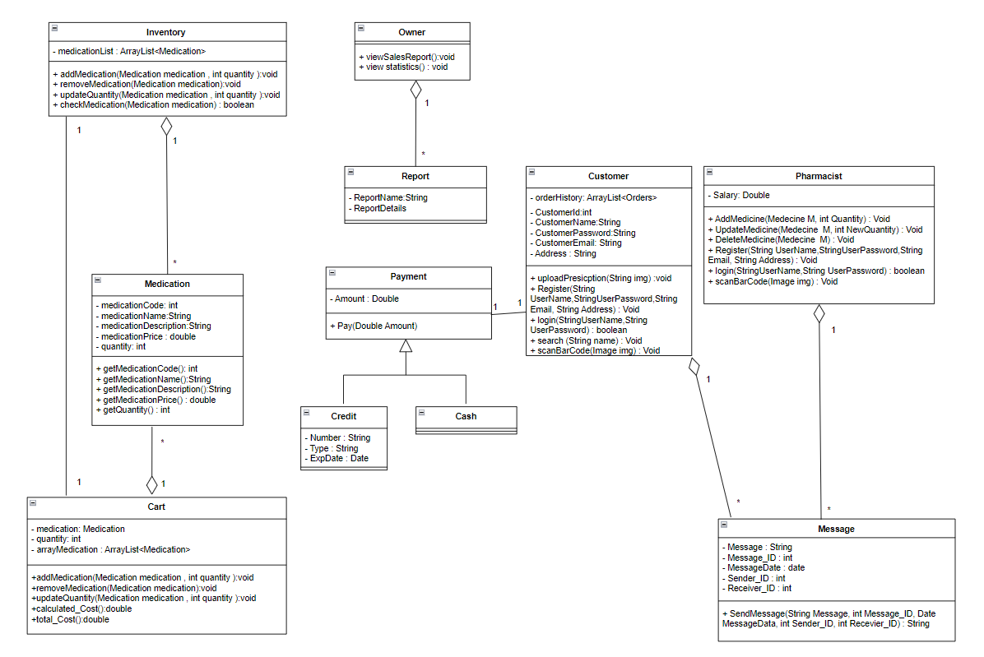

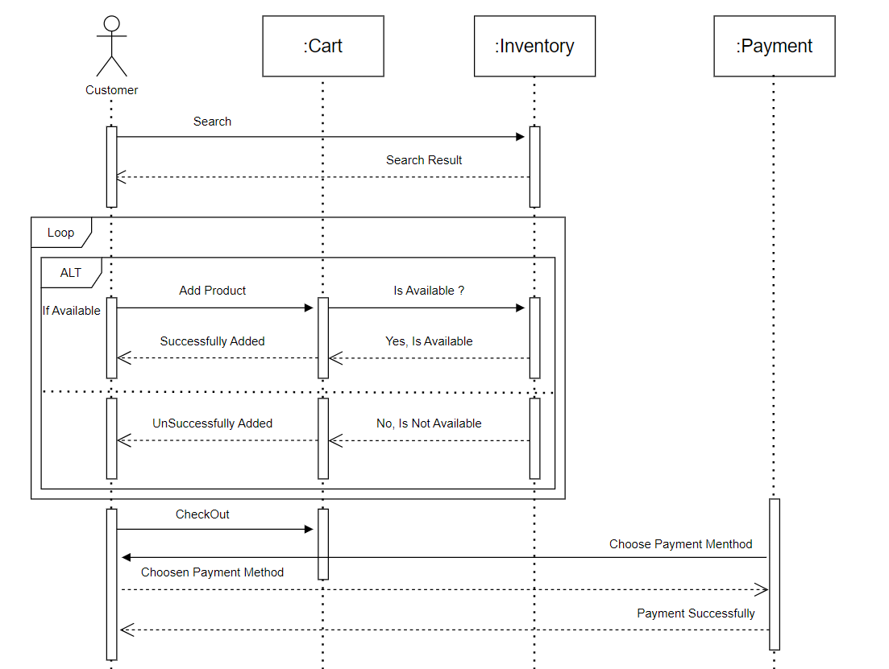
Sequence Diagram

